**CA-2 Cloud computing and virtualization**

**Name – Ashok**

**Reg.No.-12113114**

**Roll no. – RK21ITB59**

**Group - 2**

**1.Create a virtual machine and create its template and set the alarm if cpu usages is above 5%.**

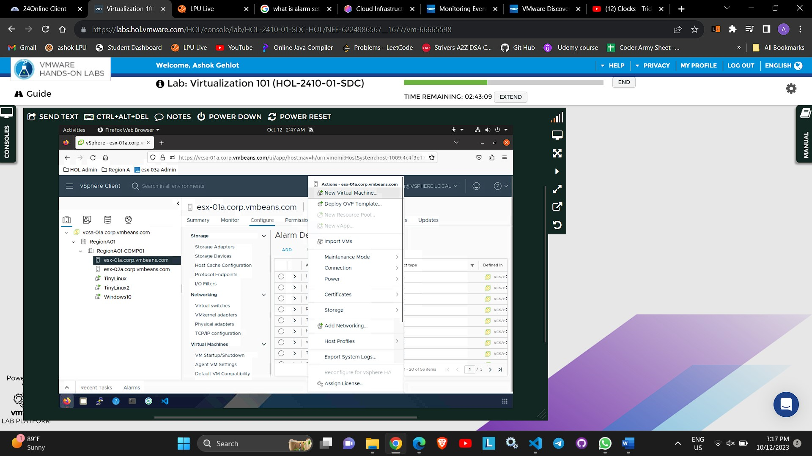

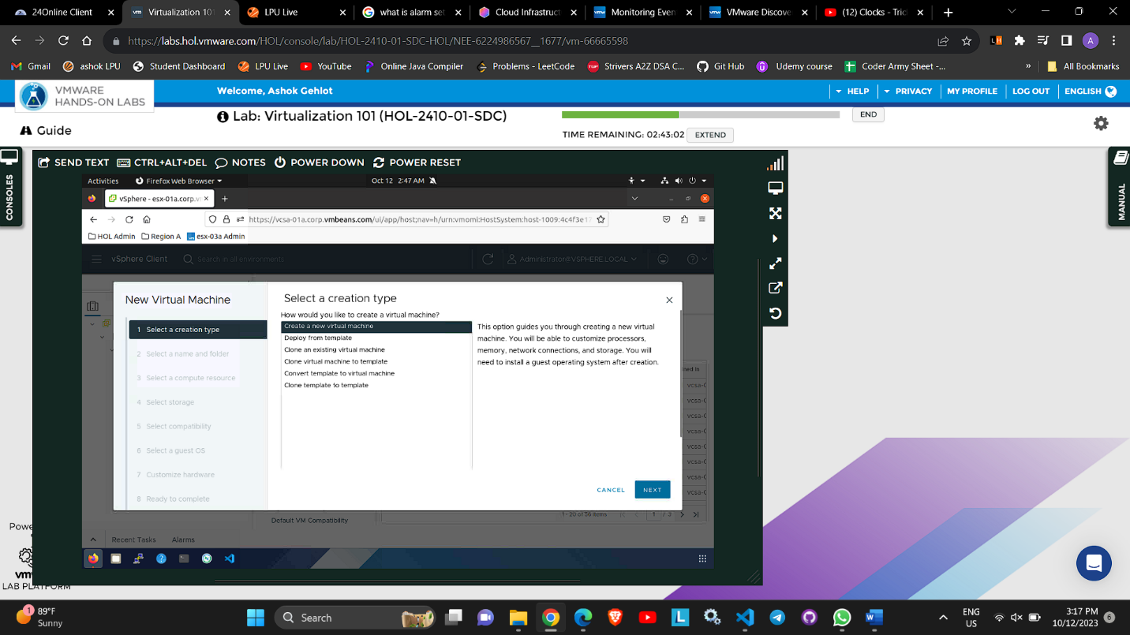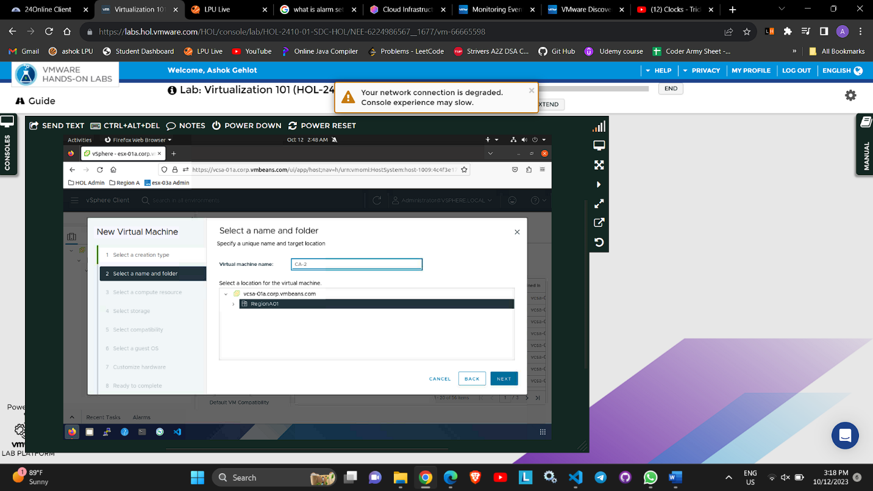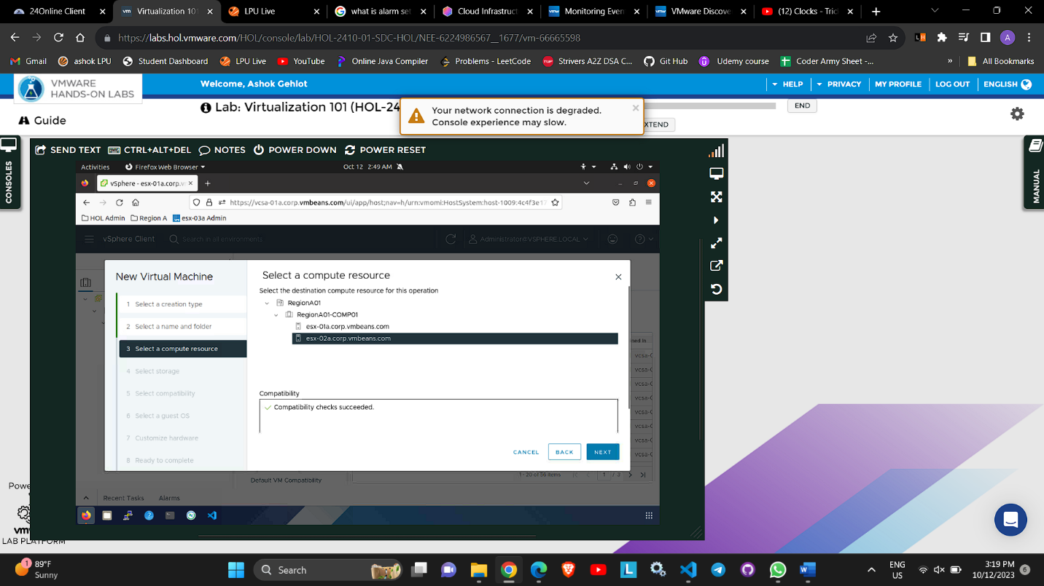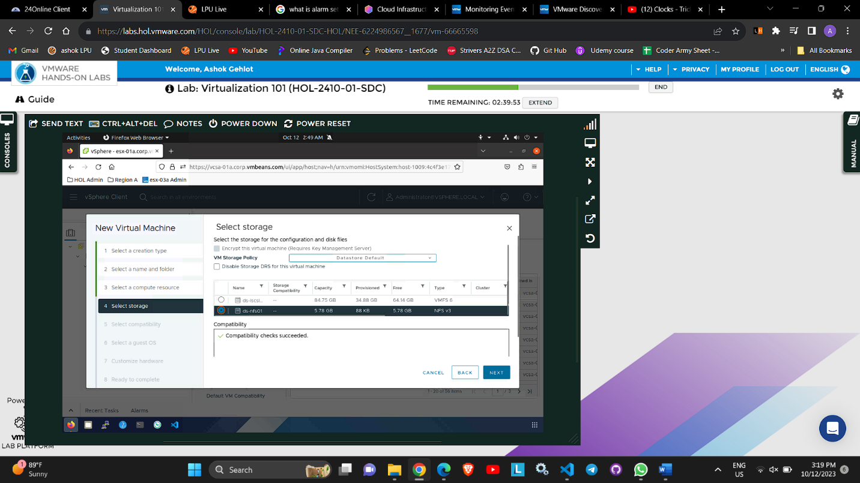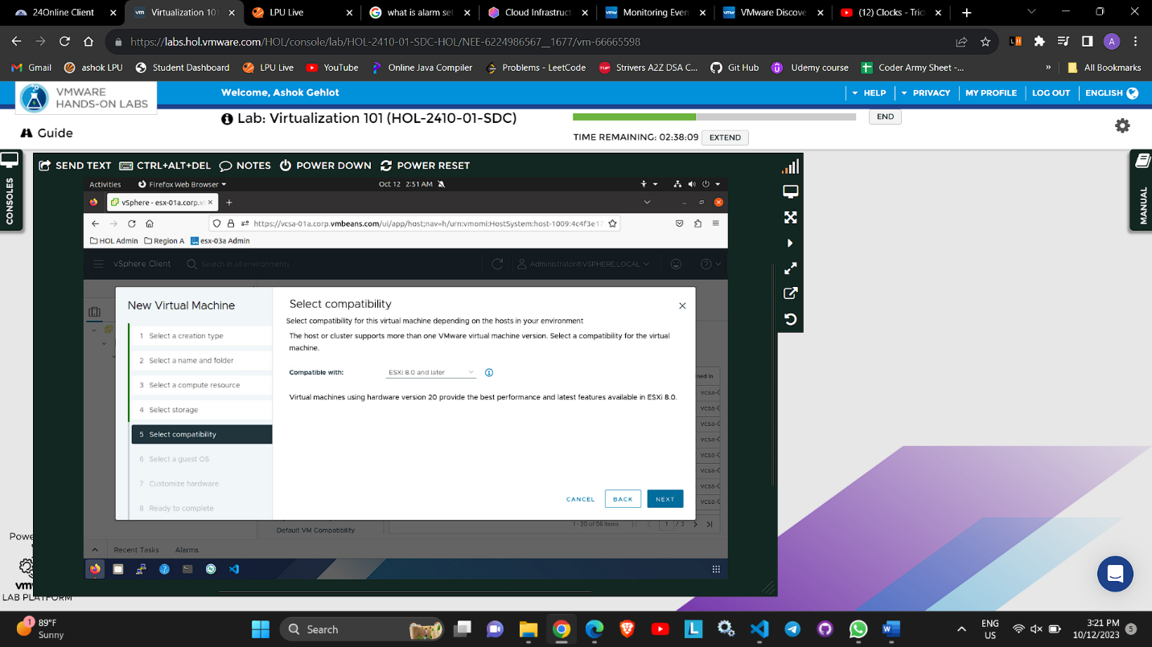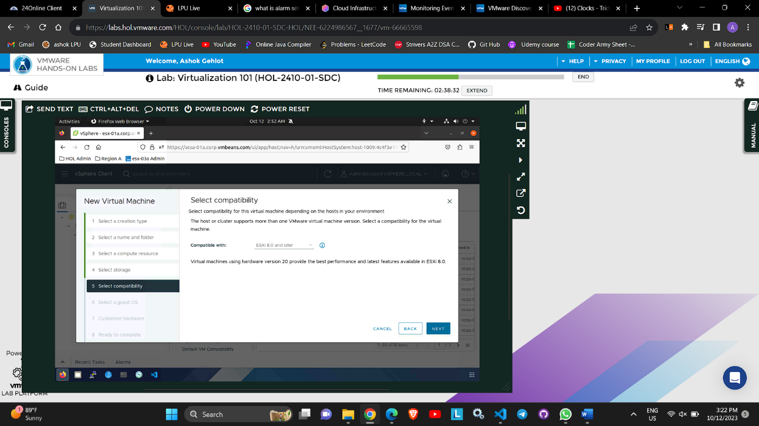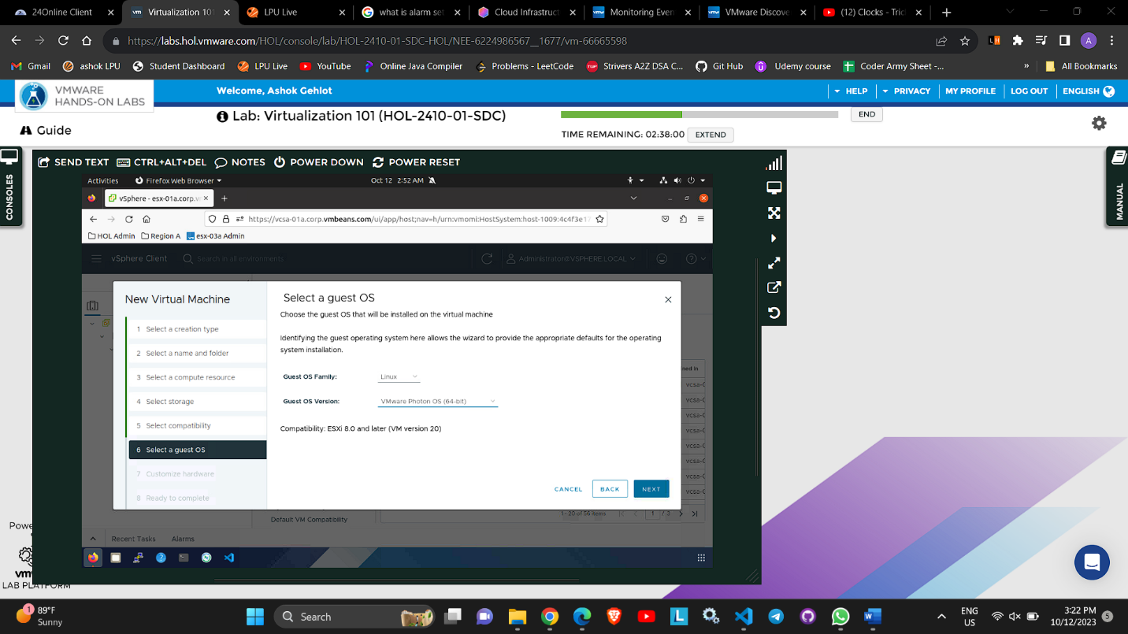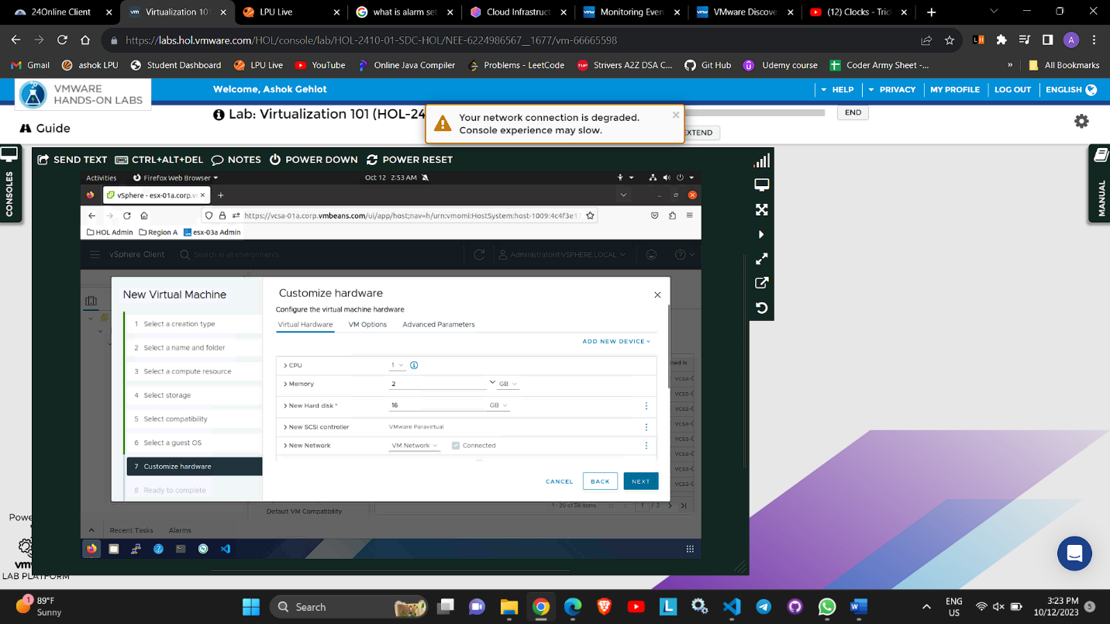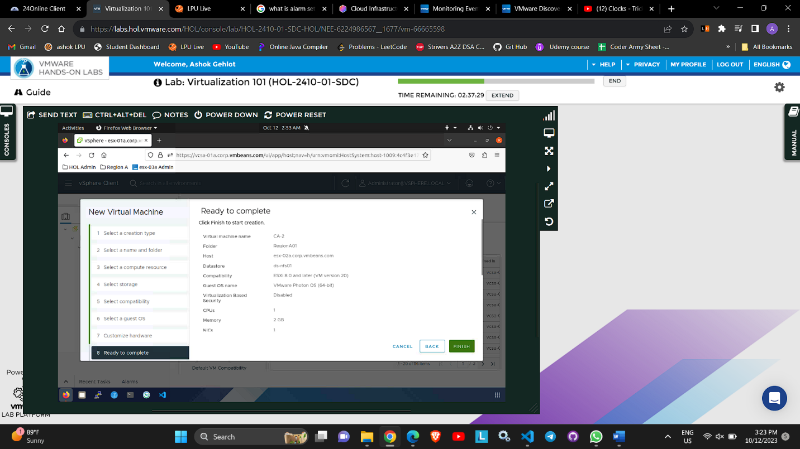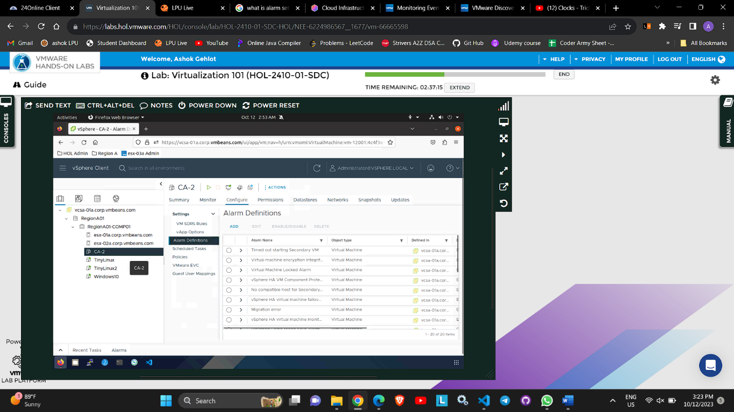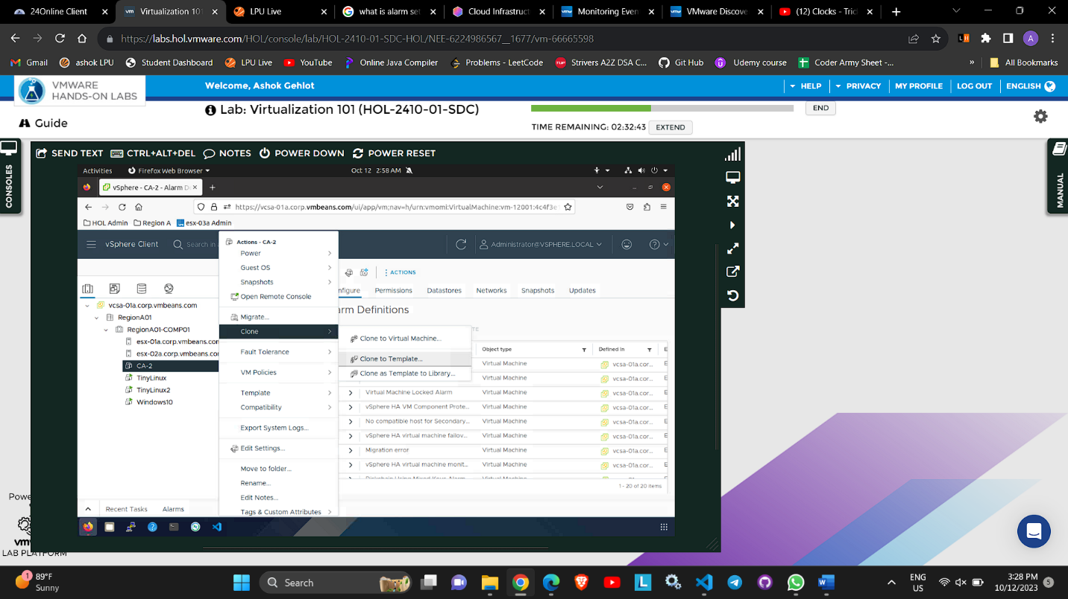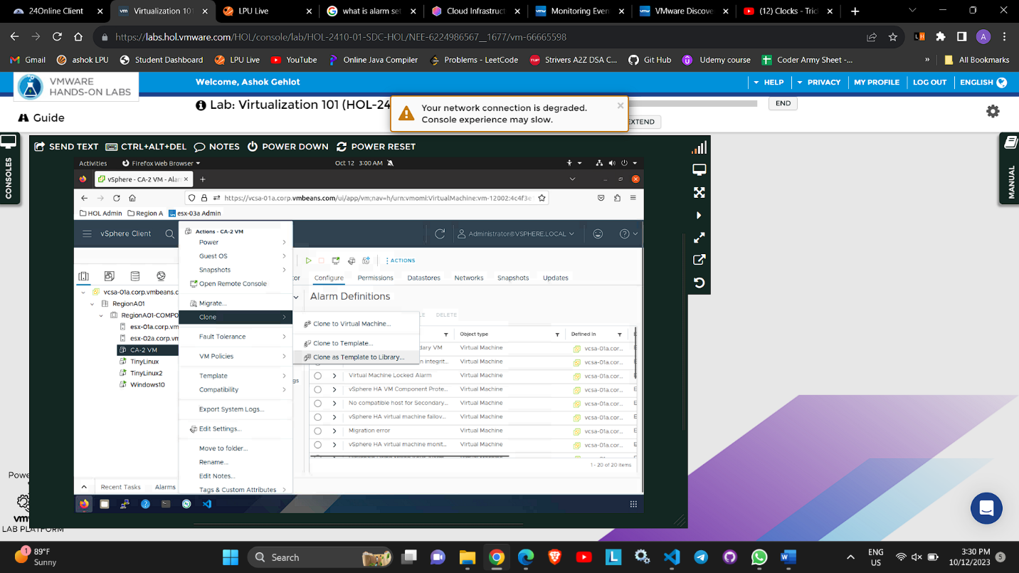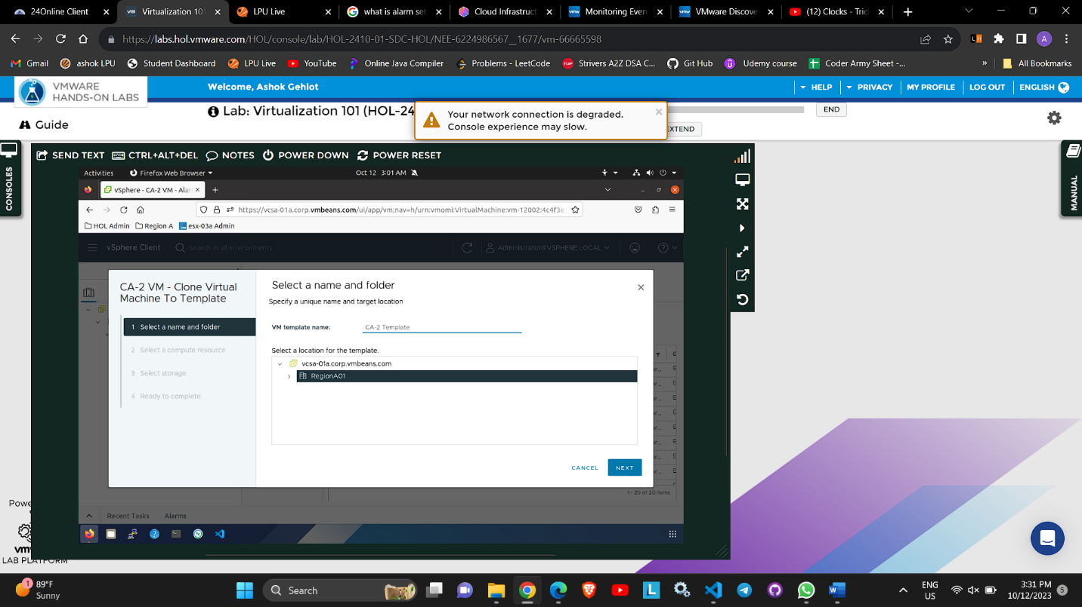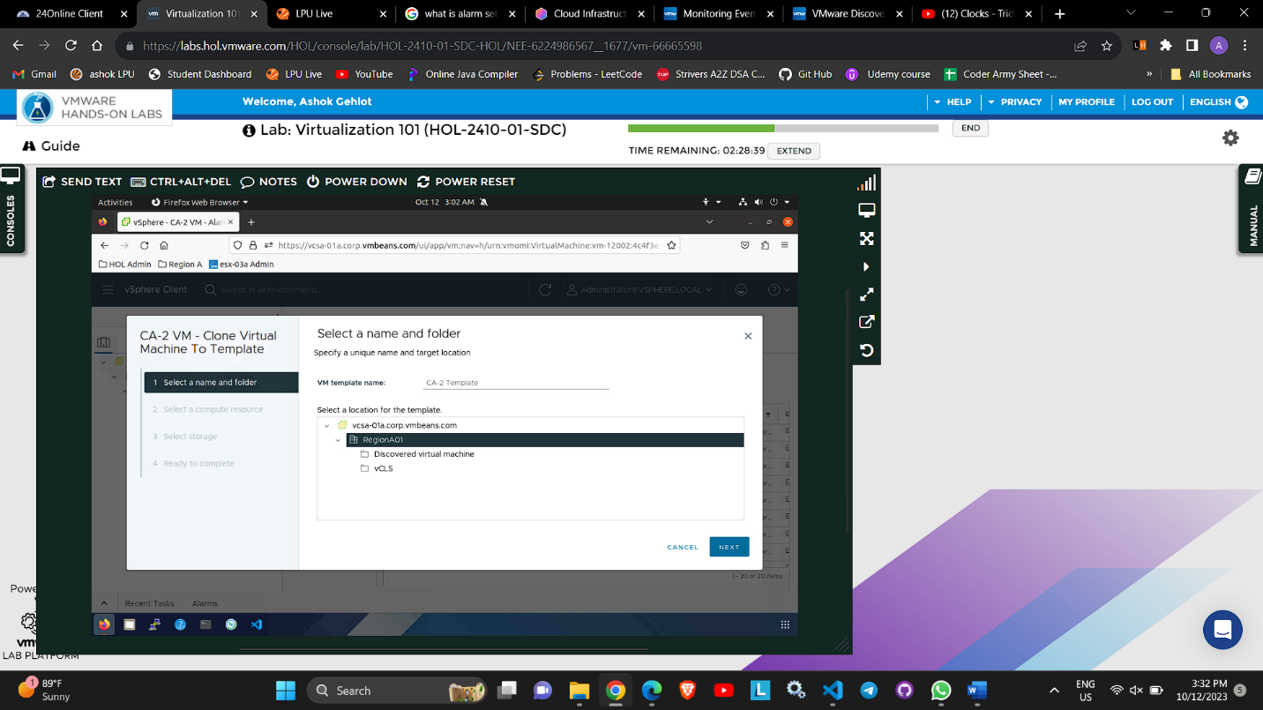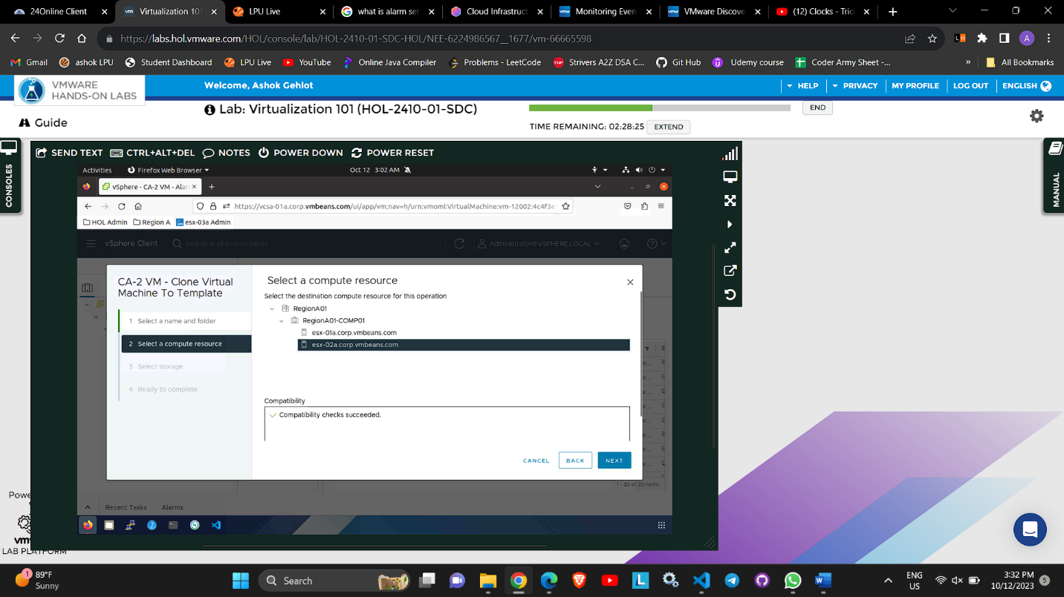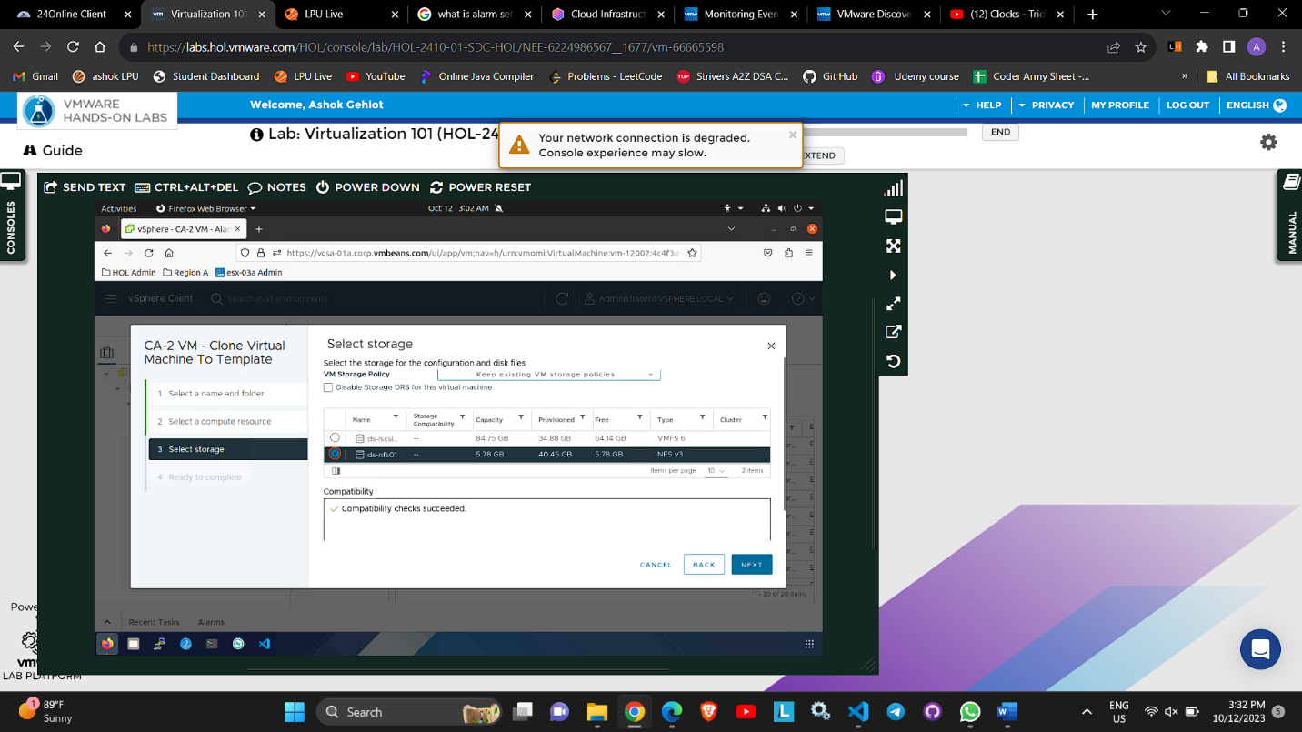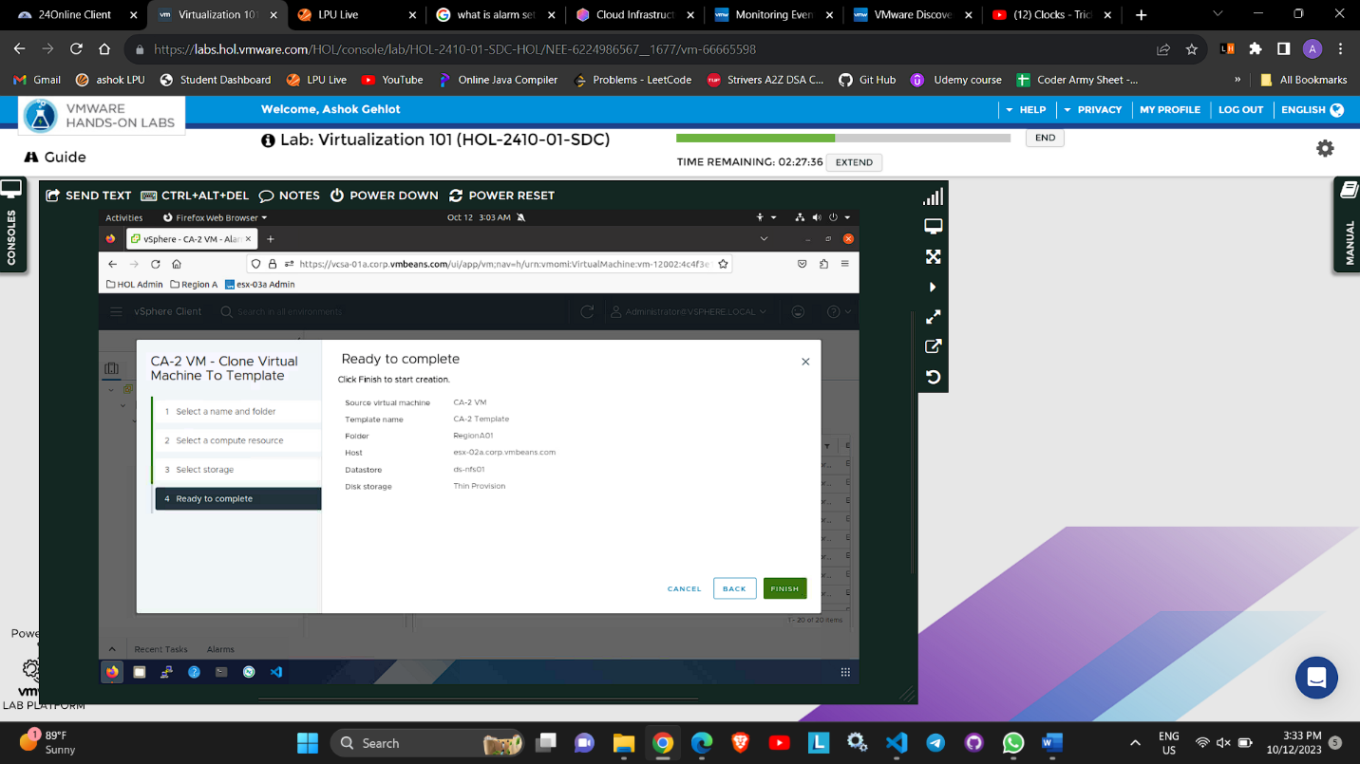

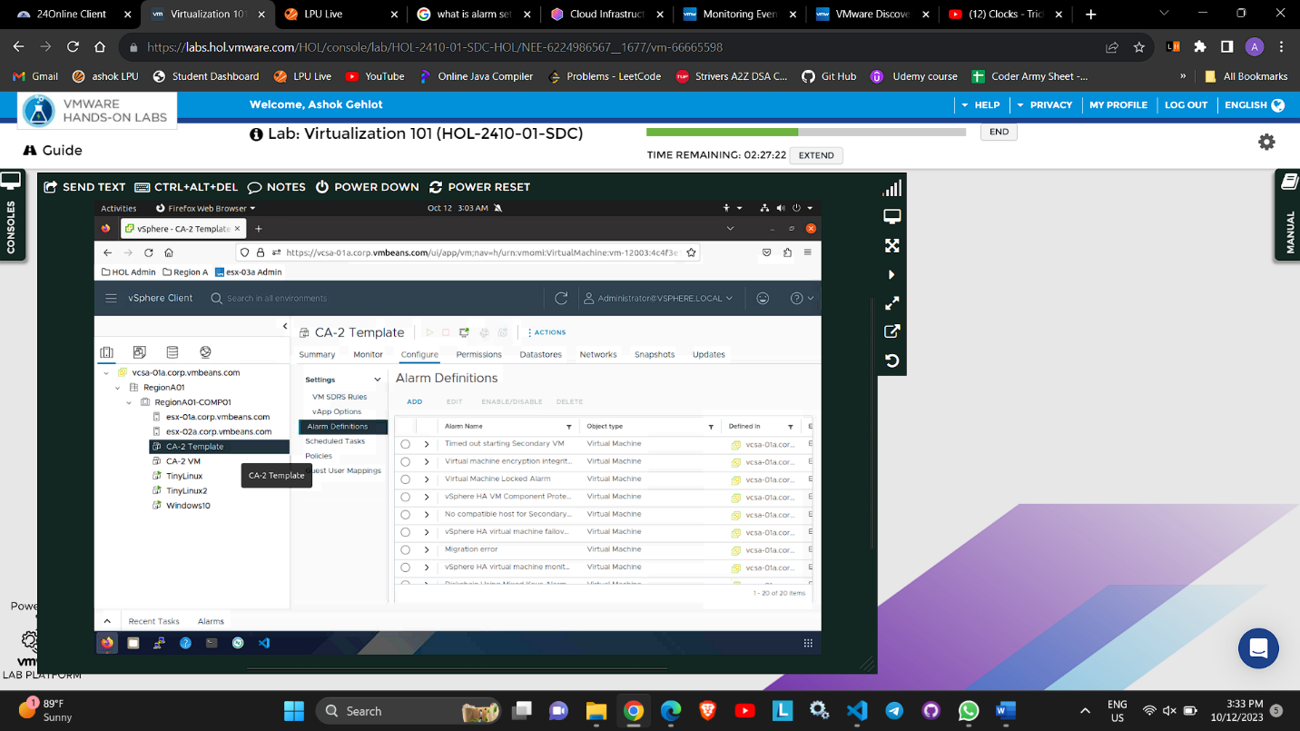

**Create New Alarm**

1. Click on the hamburger Menu on your top left

2.Click Inventory

3. Select the vCenter - vcsa-01a.corp.vmbeans.com

4.Click the Configure tab

5.Click on Alarm Definitions.

The default alarm definitions are shown. Alarms can be defined at different levels. In the case of the highlighted alarm, you can see it is defined at the top level. Alarms that are defined at the top level are then inherited by the objects below.

6. Click on the Alarm Name filter field and type "CPU" in the search field.

7.Select the Host CPU usage alarm

8.Click the new button

9. Click Next.

10.Change cpu usages is above 5 %

11.Use the scroll bar to scroll to the bottom

12. Click on Add Advanced Actions.

13.From the drop-down menu (Select an advanced action), select Enter maintenance mode.

14.Click Next

15.Click Next.

16. Click Next

17. Click Save to keep the changes made to the Alarm

